

**"Tiles Stock management"**

A PROJECT REPORT SUBMITTED TO

**THE NATIONAL INSTITUTE OF ENGINEERING, MYSURU**

(An Autonomous Institute under VTU, Belagavi)

In partial fulfillment of the requirements for Project work (Database Laboratory CS5L02),

fifth semester

**Bachelor of Engineering**

**in**

**Computer Science and Engineering**

*Submitted by*

**NARAYANI H (4NI19CS073)**

**SANJANA URS K (4NI19CS097)**

**POOJA B (4NI19CS080)**

Under the Guidance of

Nivedha S Amruthasree V M

Assistant Professor Assistant Professor



**DEPARTMENT OF COMPUTER SCIENCE AND ENGINEERING**

2021-2022

**DEPARTMENT OF COMPUTER SCIENCE AND ENGINEERING**

**THE NATIONAL INSTITUTE OF ENGINEERING**



**CERTIFICATE**

This is to certify that the project work entitled “**Tiles Stock Management**” is a work carried out by NARAYANI H (4NI19CS073), SANJANA URS K (4NI19CS097), POOJA B (4NI19CS080) in partial fulfillment for the project work (Database Laboratory – CS5L02), fifth semester, Computer Science & Engineering, The National Institute of Engineering (Autonomous Institution under Visvesvaraya Technological University, Belagavi) during the academic year 2021-2022. It is certified that all corrections and suggestions indicated for the Internal Assessment have been incorporated in the report deposited in the department library. The project work report has been approved in partial fulfillment as per academic regulations of The National Institute of Engineering, Mysuru.

**Signature of the Internal Guides**  **Signature of the HoD**

______________ _______________ _______________

Nivedha S Amruthasree V M Dr. V K Annapurna

Assistant Professor Assistant Professor Professor and Head

Dept. of CS&E

NIE, Mysuru

**Signature of the Examiners with date**

_________________ _________________

Name: Name:

Designation: Designation:

**Acknowledgements**

Tiles stock management has been developed successfully with a great contribution of many people in a period of one year. We like to appreciate their guidance, encouragement and willingness since without their support the project would not have been a success.

We avail this opportunity to express out deep sense of gratitude to our project guide and supervisor Nivedha, Assistant Professor of department of Computer Science & Engineering, The National Institute of Engineering Mysore, for her excellent guidance, timely support suggestions and all the help in carrying out this project right from the selection of the topic to submission of report to the institute and remained ever grateful to you madam.

Our utmost and deep sense of gratitude to Dr. V K Annapurna, Professor and HOD, Department of Computer Science and Engineering, The National Institute of Engineering, Mysuru for providing guidance, necessary help and co-operation in regard to this task.

We feel pleasure to thank all our senior friends and others whose smiles made our painstaking project work easy.

Finally, our special thanks are due to all those who have helped us directly and indirectly and who have supported us positively in the successful completion of this project.

- NARAYANI H (4NI19CS073)

- SANJANA URS K (4NI19CS097)

- POOJA B (4NI19CS080)

**Table of Contents**

|  |  |  |
| --- | --- | --- |
| **Sl No.** | **Contents** | **Page No.** |
| 1 | Introduction | 6 |
| 2 | System Analysis | 8 |
| 3 | System Design | 9 |
| 4 | System Implementation | 11 |
| 5 | System Testing | 26 |
| 6 | Conclusion | 27 |

**List of Figures**

|  |  |  |
| --- | --- | --- |
| **Figure no.** | **Description** | **Page** |
| 3.1 | Representation of a particular tile type | 10 |
| 3.2 | ER Diagram | 10 |
| 4.1 | Home page | 11 |
| 4.2 | Product page | 13 |
| 4.3 | Vitrified page | 13 |
| 4.4 | Sanitary page | 14 |
| 4.5 | Kitchen page | 15 |
| 4.6 | Accessories | 17 |
| 4.7 | Home page of stock | 18 |
| 4.8 | Add option | 20 |
| 4.9 | Graphical display of sales | 20 |
| 4.10 | Sales entry form | 21 |
| 4.11 | Purchase entry form | 22 |
| 4.12 | Adhesive table | 23 |
| 4.13 | Name table | 23 |
| 4.14 | Border table | 23 |
| 4.15 | Sales table | 24 |
| 4.16 | Purchase table | 24 |
| 4.17 | Sanitary table | 24 |
| 4.18 | Size table | 25 |
| 4.19 | Tap table | 25 |
| 4.20 | Type table | 25 |
| 4.21 | Vitrified table | 25 |

**Chapter - 1**

**Introduction**

**1.1 Overview**

Tiles stock management is a website made for people to check different tiles virtually. This website displays different tiles like vitrified, parking, kitchen, border, taps, basin, and sanitary ware. Each type has a name, size, and image. It contains contacts of the company, map, and other social media platform links.

For admin, there is a stock management system. It displays a list of today's sales, a list of out-of-stock, a list of total stock, a list of different types, sizes, names, batches, materials. It has forms to insert new sizes, new names, from and to the sales list. Sales is displayed pictorially also using graphs. You can enter sales and purchases. On submitting it displays the current stock of the company.

We had meetings and brainstormed ideas and designs for web development. After a week, we finalized a template and design for the website. We collected tile's names, sizes, and researched relevant information of the same.

The next phase was to get started with using HTML, CSS, and bootstrap to build the website. The documentation was finalized where one person explained and everyone pitched in to make final adjustments. All in all, this project not only helped us refine our skills in web development, but it also helped us learn more about the tiles, helped us with our teamwork and understanding.

**1.2 Tiles**

**Tiles** are usually thin, square, or rectangular coverings manufactured from hard-wearing material such as ceramic, stone, metal, baked clay, or even glass. They are generally fixed in place in an array to cover roofs, floors, walls, edges, or other objects such as tabletops. In another sense, a tile is a construction tile or similar object, such as rectangular counters used in playing games (see tile-based game). The word is derived from the French word tuile, which is, in turn, from the Latin word tegula, meaning a roof tile composed of fired clay.

Tiles are found in different sizes like 2/2, 4/2, 32/32, shapes like square, rectangle, designs like freehand, plain, patched, materials like glass, ceramics, wood, etc. Tiles being a major part of human-like, not many people know about its categories. In this pandemic situation going to shops with family to choose tiles for their dream homes is not possible. So we planned to make a website which they can use in the current situation.

**Chapter-2**

**System Analysis**

* 1. **Existing system explanation**

Usually, tiles stock management is made in books. When load comes it is recorded in the purchase book and on sales, it is recorded in the sales book. In this method, there is no record of finding the total stock at a particular time, you can't find the total numbers of boxes and pieces of particular tiles. Because of this, you are not sure which tile should we display to the customer.

**2.2 Proposed system explanation**

On this website, just by entering the sales and purchases on this website, you can see the total stock, out-of-stock, and today's sales list. This helps you to understand the most sold and the least sold tiles in the company. Also, you can see the graphical representation of the sales. And for customers, the website can be used as a catalog to show different tiles available in the company.

* 1. **System Requirements**

For customer use, if the website is the host then we can open it in any browser. For admin, he should have MySQL installed and tables created or database in the cloud.

**2.4 Statement of the problem**

We are building a website on tiles stock management. It comprises different types of tiles. Each type has different measurements. Each measurement has a different design name. Each design has different batches. Each measurement has a specified number of pieces in a box. For sanitary ware, it has only names. We will be giving inward and outward (purchase of tiles and sales of tiles) options for measurements, design names, batches. Most stock management is done manually. This application will give computerized stock management, list of out of stock tiles, frequently sold type of tiles, and daily stock sheet.

**Chapter-3**

**System Design**

**3.1 System Architecture**

In the front end, it contains about, products, stock. Products include different items sold by the company. Each item has a name, size, and one image. In the backend, different tables are created to store the data. Foreign keys are used to connect them. There are 10 tables vitri, nametable, sizetable, sales, purchase, typetable, border, adhe, sani, and tap. Nametable, sizetable and typetable are connected to other tables with foreign keys. We have used 5 views vitrified, borderr, adhesive, sanitary, and tapp.

In typetable, there are different types of tiles like vitrified, flooring, parking, etc. Each name has an id as a primary key. In nametable, there are different names are listed like Diana, basin, shower tap, pedestal, EWC, Premier, Classic, Moonlight, Romano, Nova, Firm, Basin tap, Pencil, etc. Each name has an id as a primary key. In sizetable, there are different sizes are listed like 2/2, 4/2, 32/32, 800/1600, 200/1200, 16/16, 1/1, etc. Each name has an id as a primary key.

In vitri table, it contains different combinations with the number of boxes, pieces, and cost per box. In sani table, it contains different combinations with the number of pieces and cost per piece. In tap table, it contains different combinations with the material, number of pieces, and cost per piece. In border table, it contains different combinations with the number of pieces and cost per piece. In adhe table, it contains different combinations with the weight, number of pieces, and cost per piece.

In sales table, it stores all the sales lists entered by the admin. In purchase table, it stores all the purchase lists entered by the admin. It has 5 views. These are used to create a table connecting all foreign keys. They are used in displaying data on the website.

**3.2 ER Diagram**

An Entity-relationship model (ER model) describes the structure of a database with the help of a diagram, which is known as the Entity-Relationship Diagram (ER Diagram). An ER model is a design or blueprint of a database that can later be implemented as a database. The main components of the E-R model are entity set and relationship set.

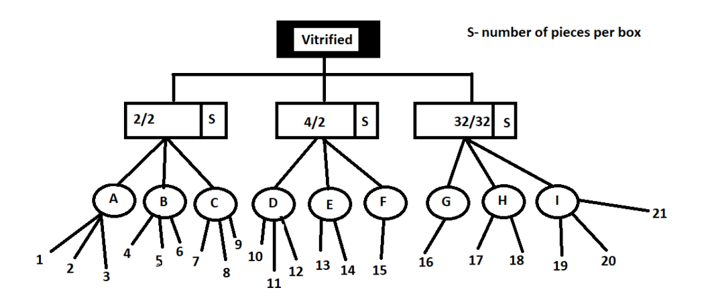

**Fig 3.1 Representation of a particular tile type**

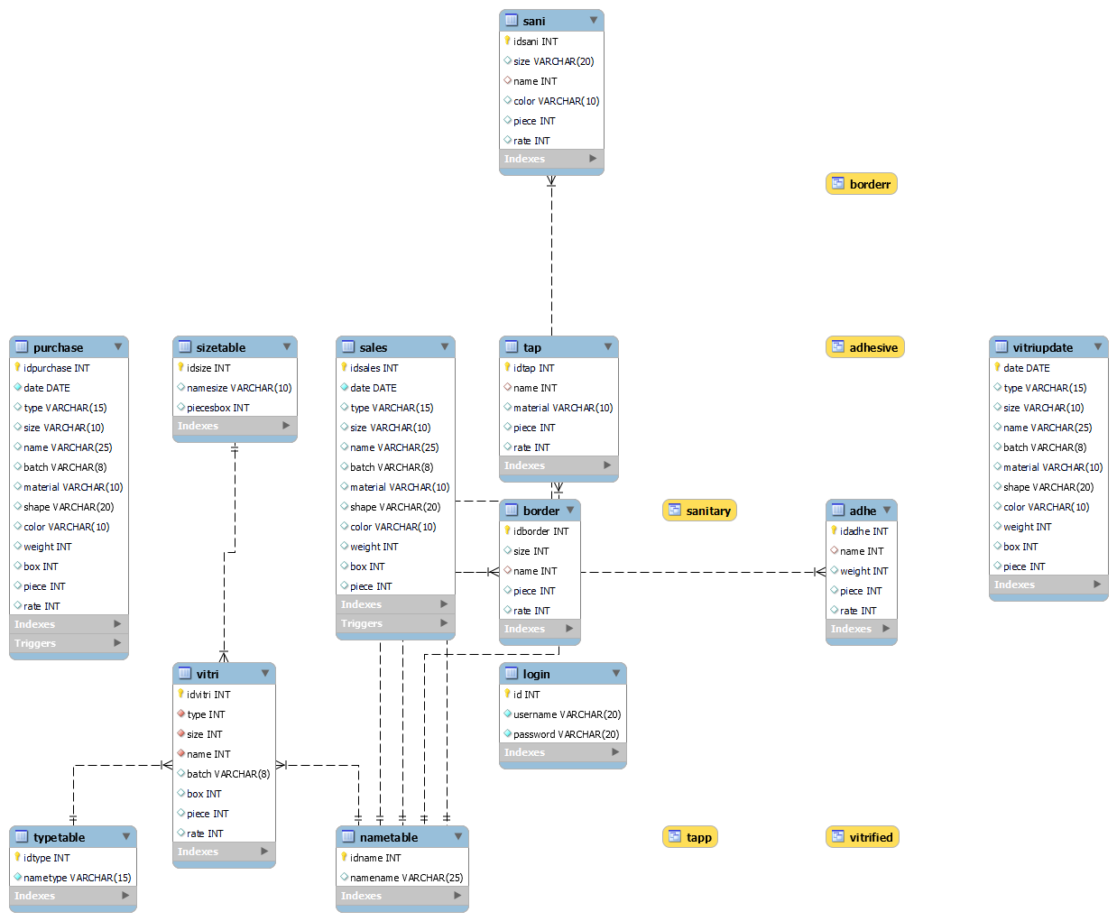

**Fig 3.2 ER Diagram**

**Chapter – 4**

**System Implementation**

The tools used in making the website are

* Hypertext Markup Language (HTML)
* Cascading Style Sheets (CSS)
* JavaScript (JS)
* Bootstrap
* Hypertext Preprocessor(PHP)
* MySQL database.

**4.1 Front end**

The home page consists of a logo, navbar, carousel pictures, explore, and footer section. Navbar contains about the company, products, and stock buttons. Explore section contains pictures that are links to other pages. Products have sub-list vitrified, sanitary, kitchen, and accessories. The Footer section has links to social media sites contact details and a map to the company.

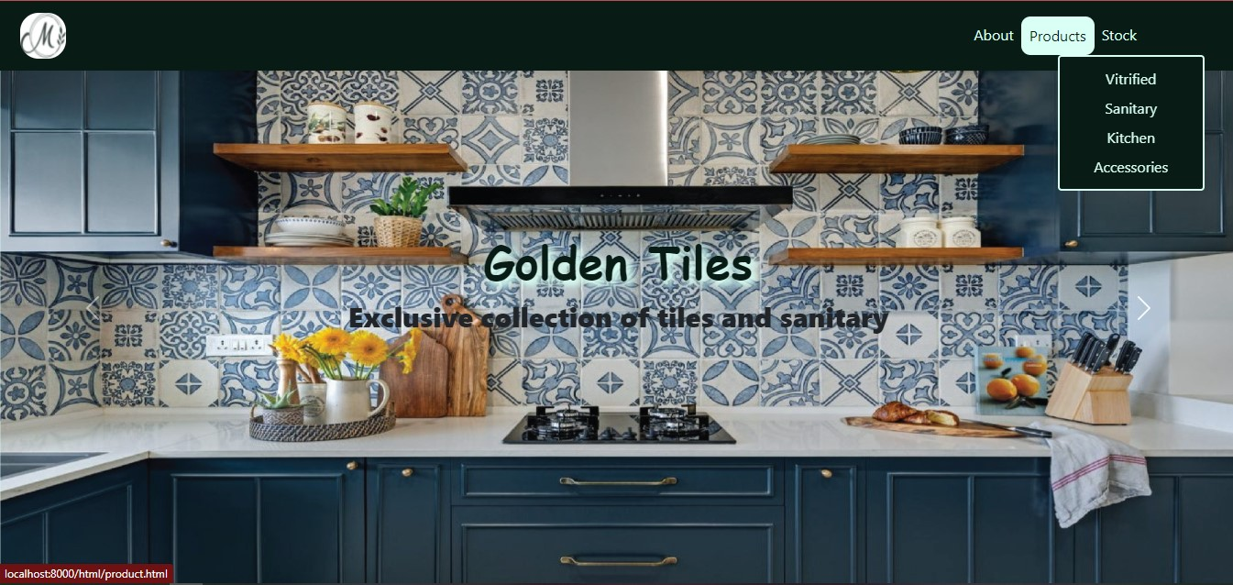

**Fig 4.1 (a) Homepage**

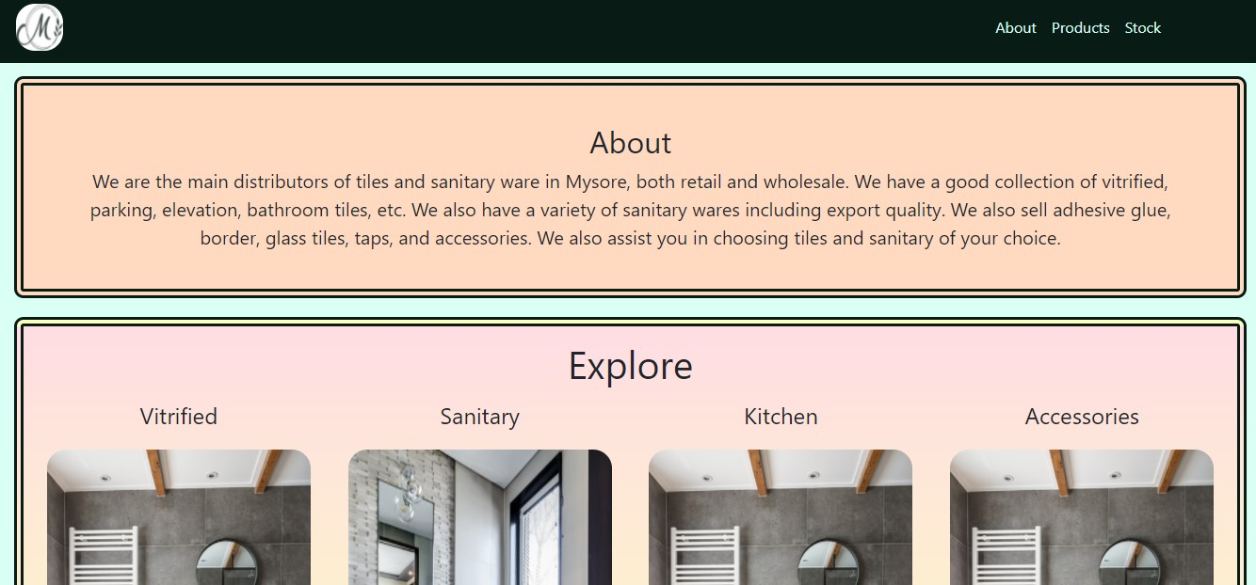

**Fig 4.1 (b) Homepage**

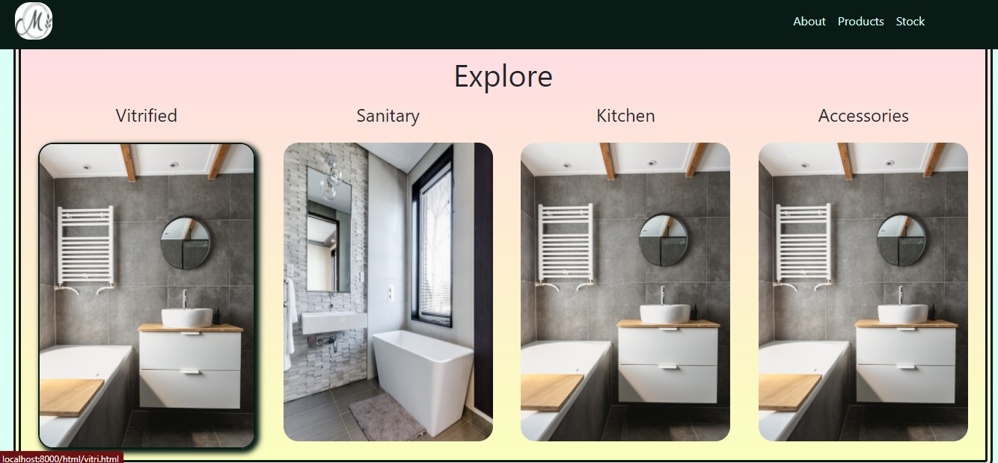

**Fig 4.1 (c) Homepage**

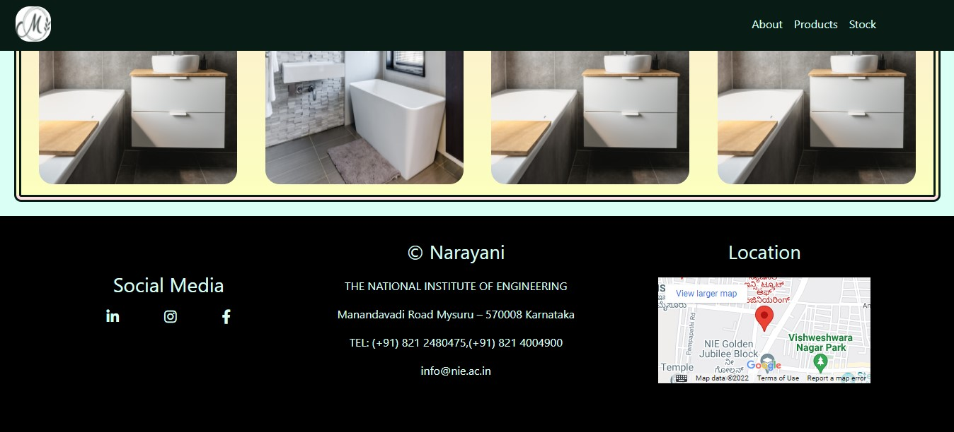

**Fig 4.1 (d) Homepage**

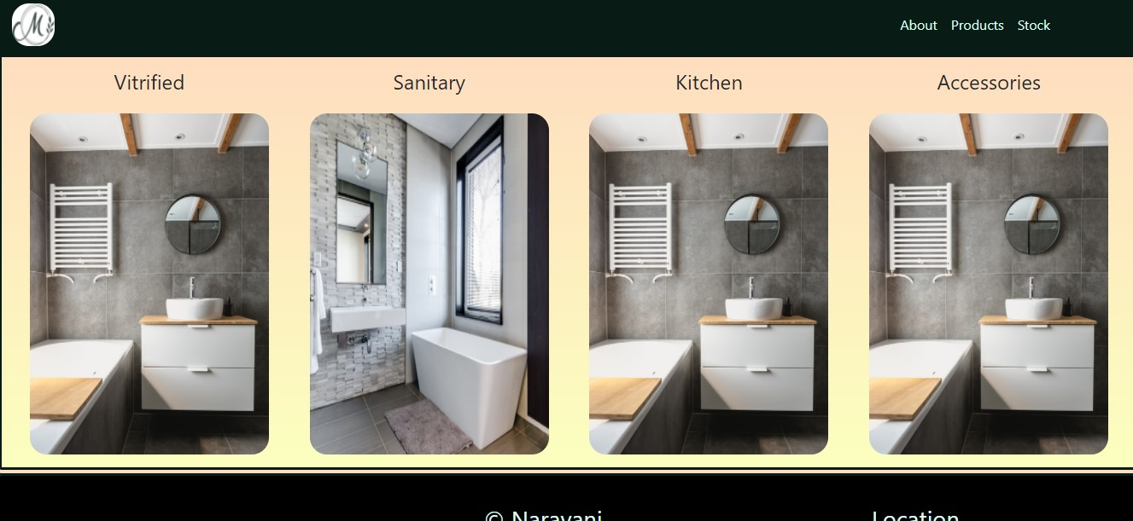

**Fig 4.2 Products page**

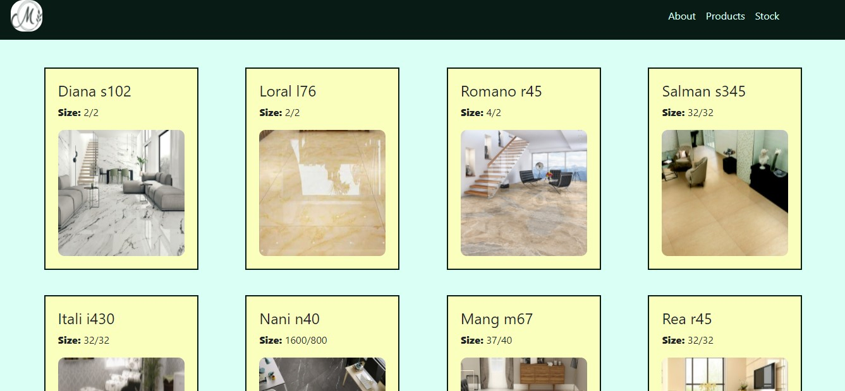

**Fig 4.3 (a) Vitrified page**

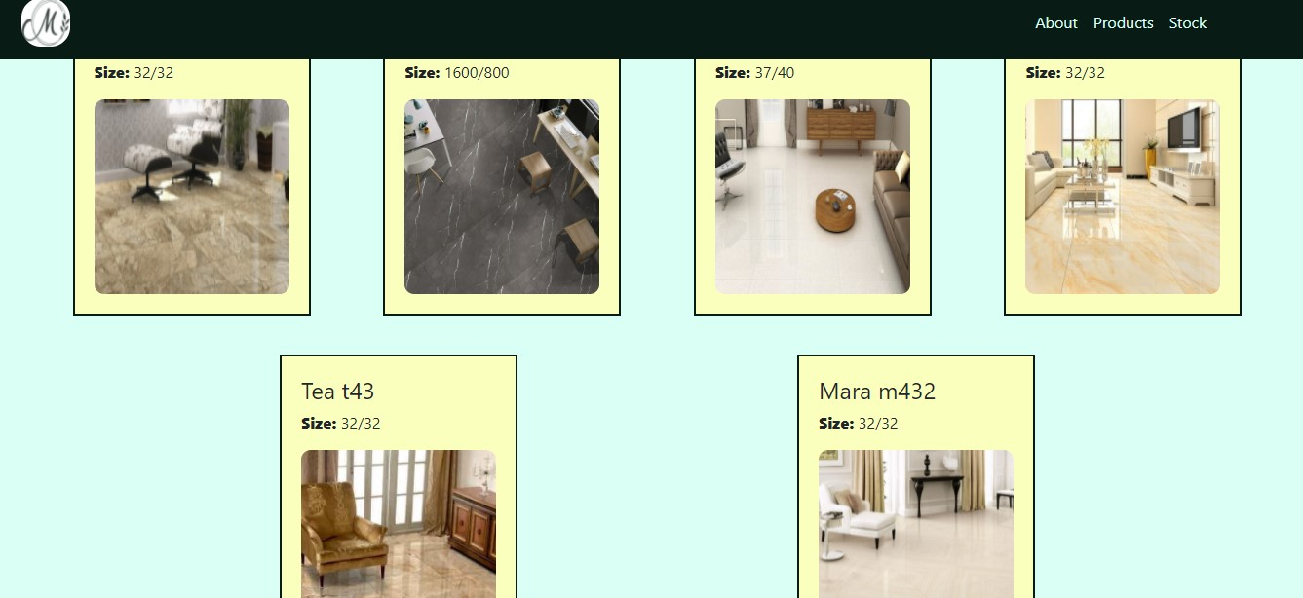

**Fig 4.3 (b) Vitrified page**

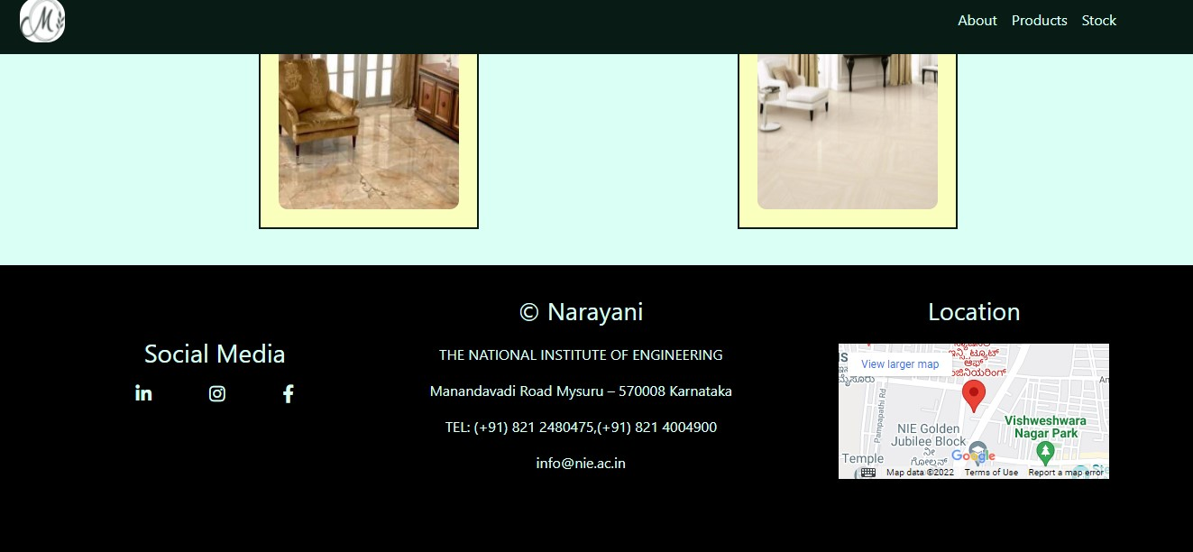

**Fig 4.3 (c) Vitrified page**

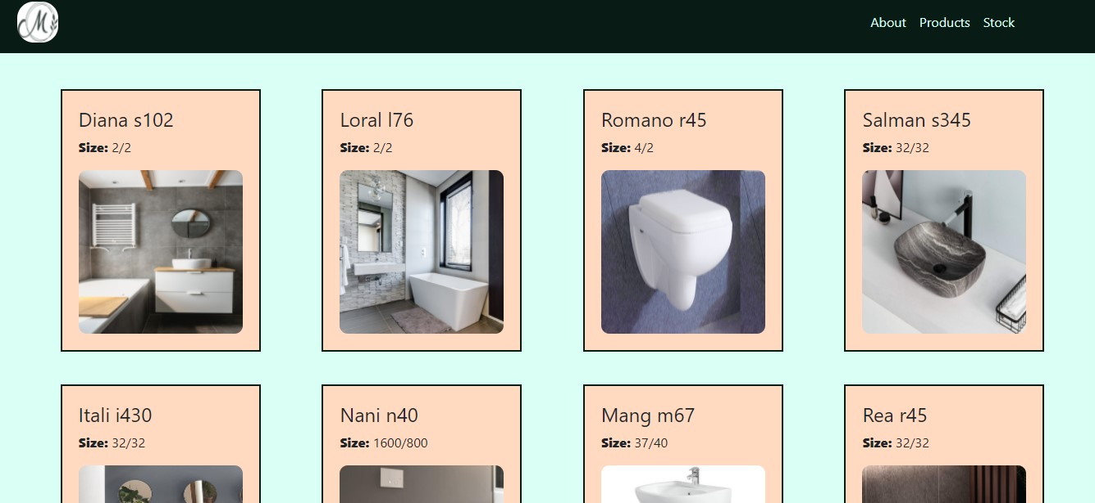

**Fig 4.4 (a) Sanitary page**

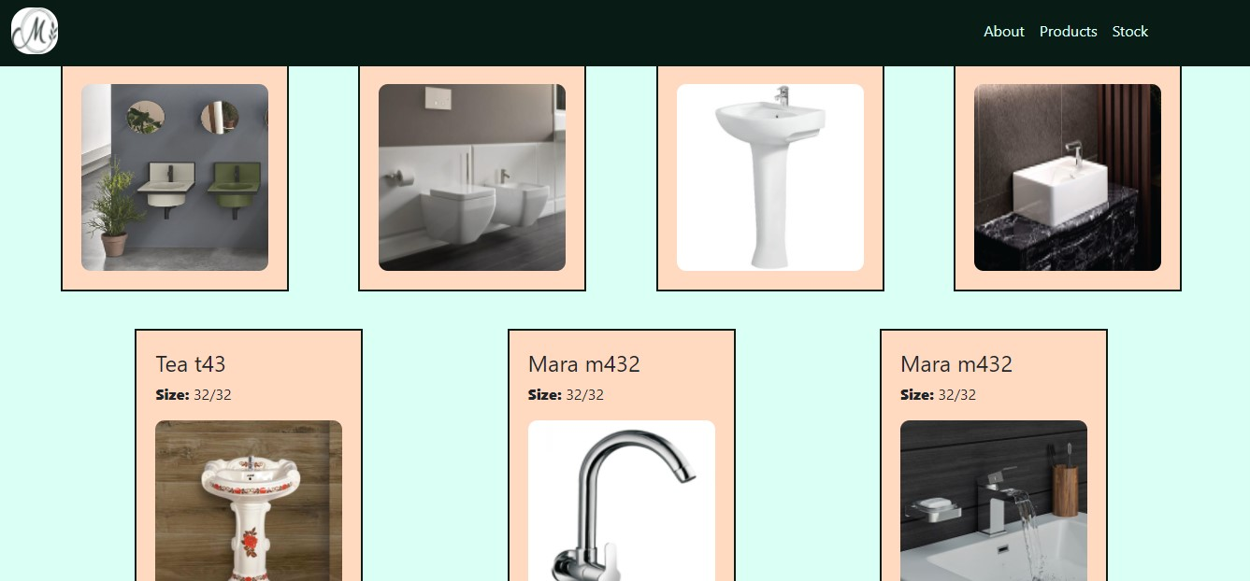

**Fig 4.4 (b) Sanitary page**

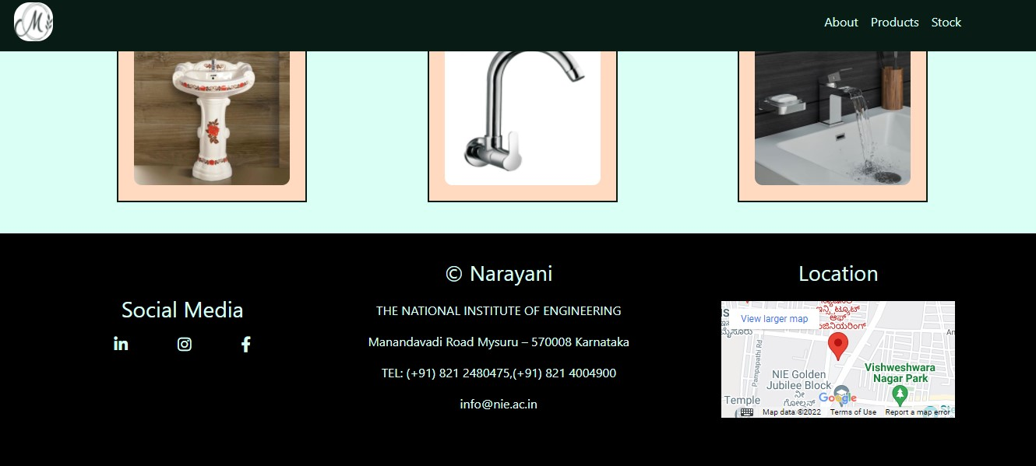

**Fig 4.4 (c) Sanitary page**

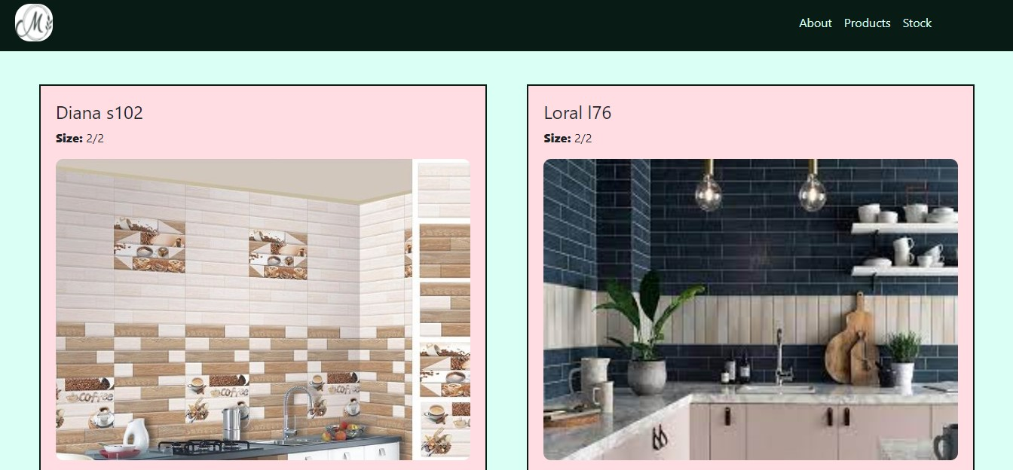

**Fig 4.5 (a) Kitchen page**

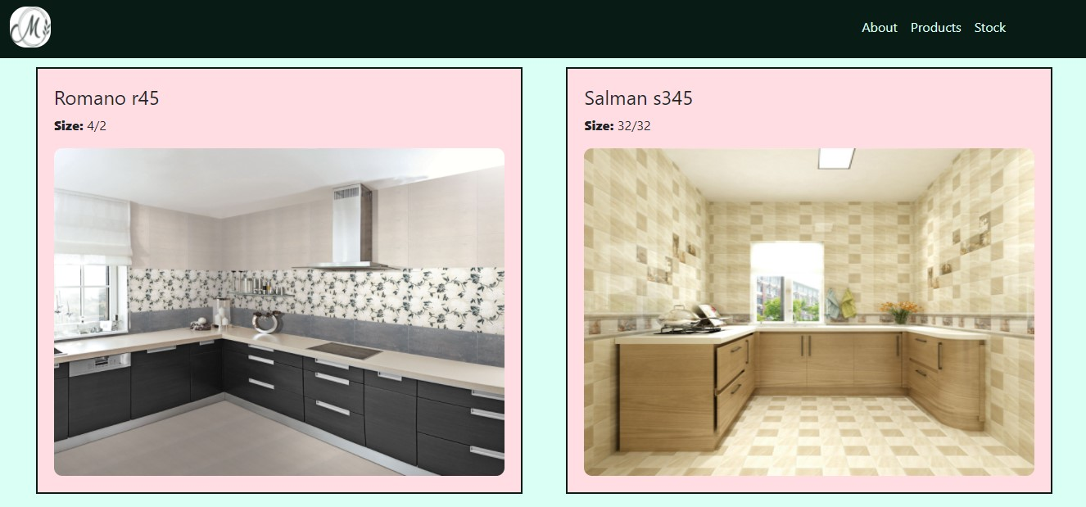

**Fig 4.5 (b) Kitchen page**

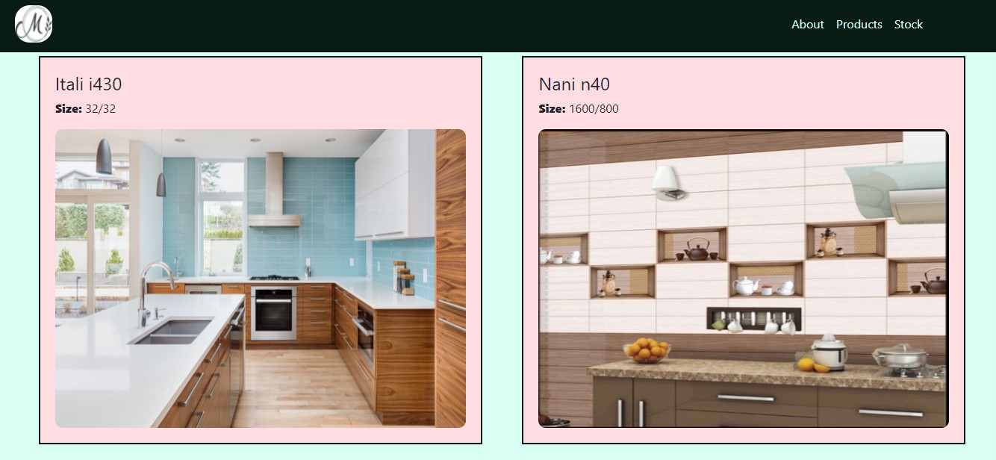

**Fig 4.5 (c) Kitchen page**

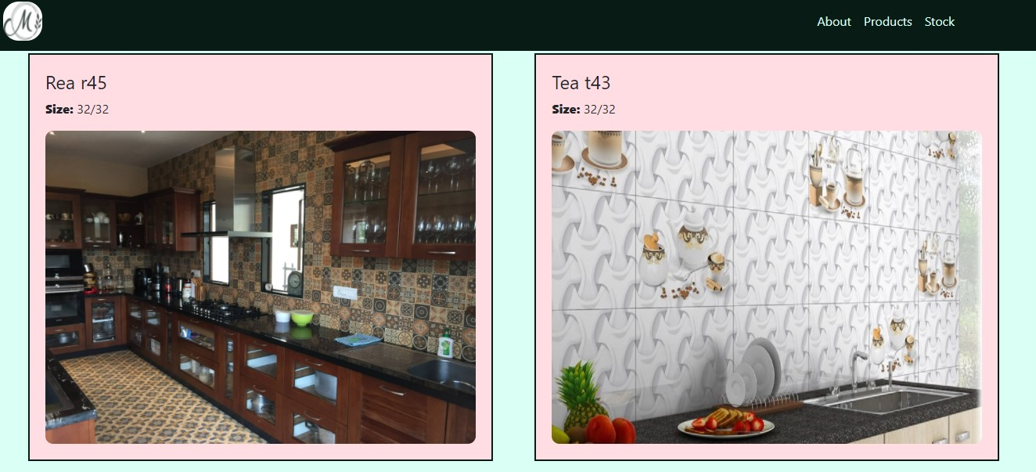

**Fig 4.5 (d) Kitchen page**

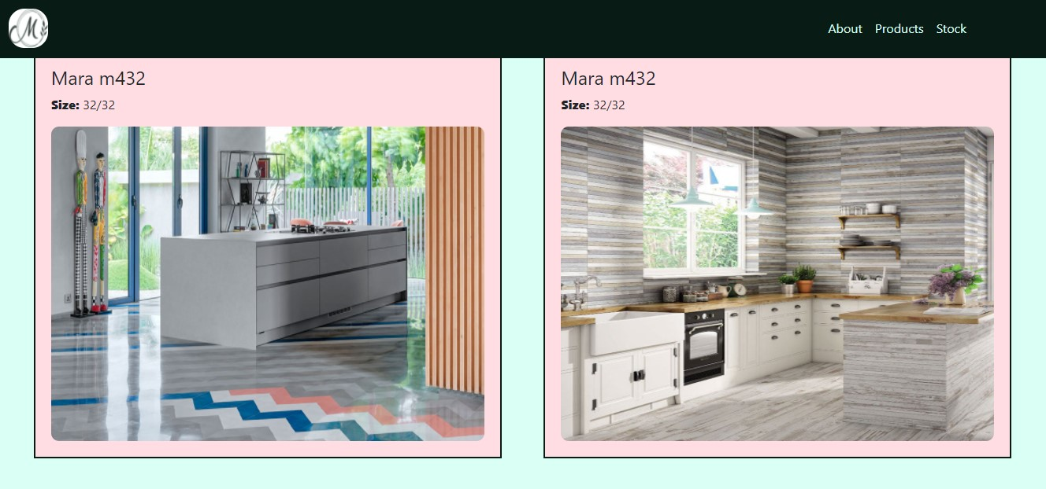

**Fig 4.5 (e) Kitchen page**

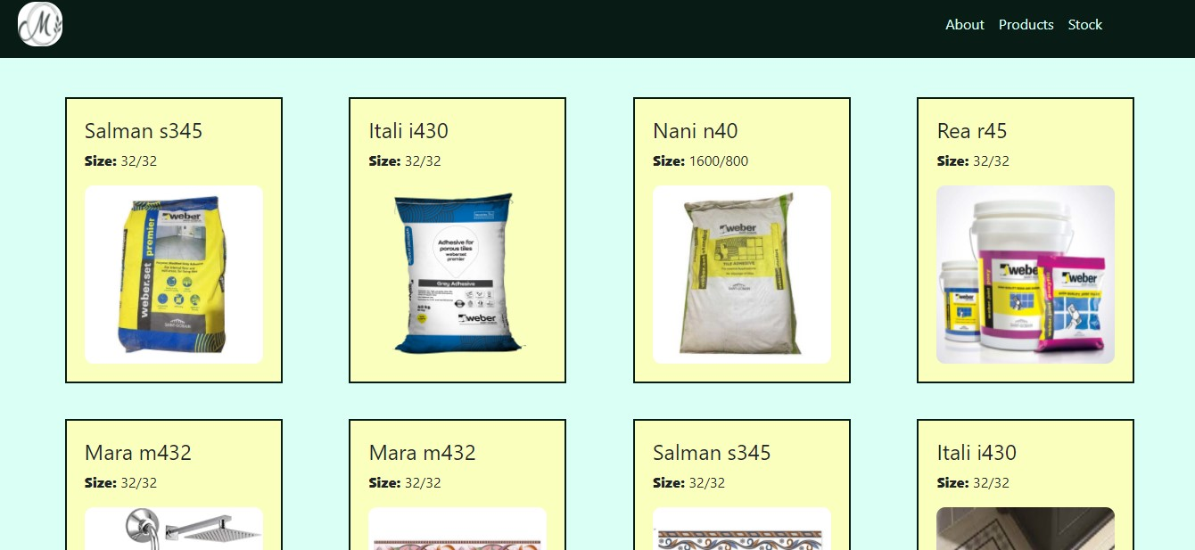

**Fig 4.6 (a) Accessories page**

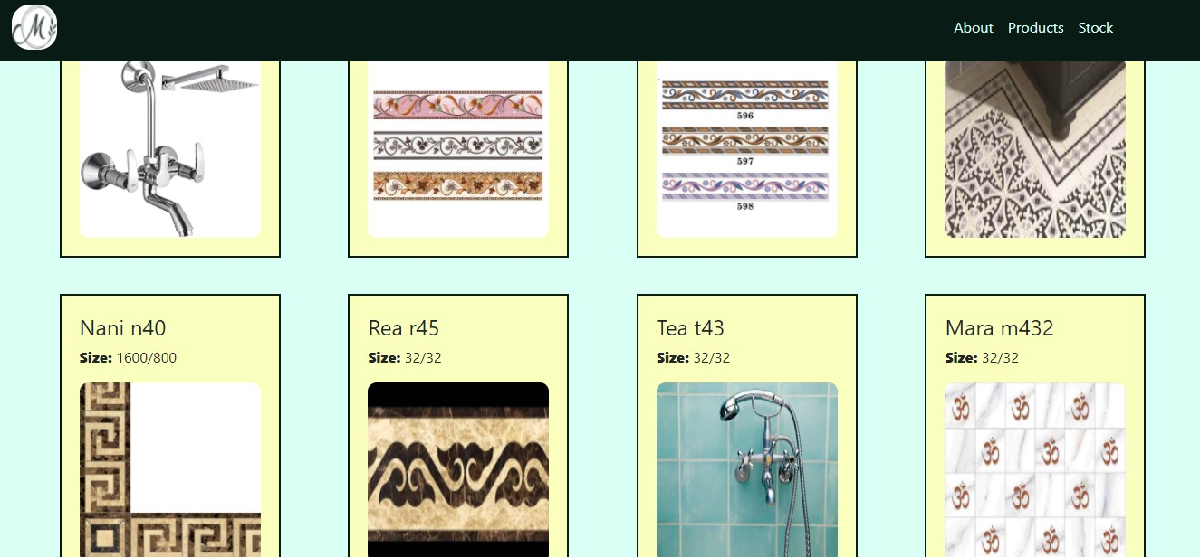

**Fig 4.6 (b) Accessories page**

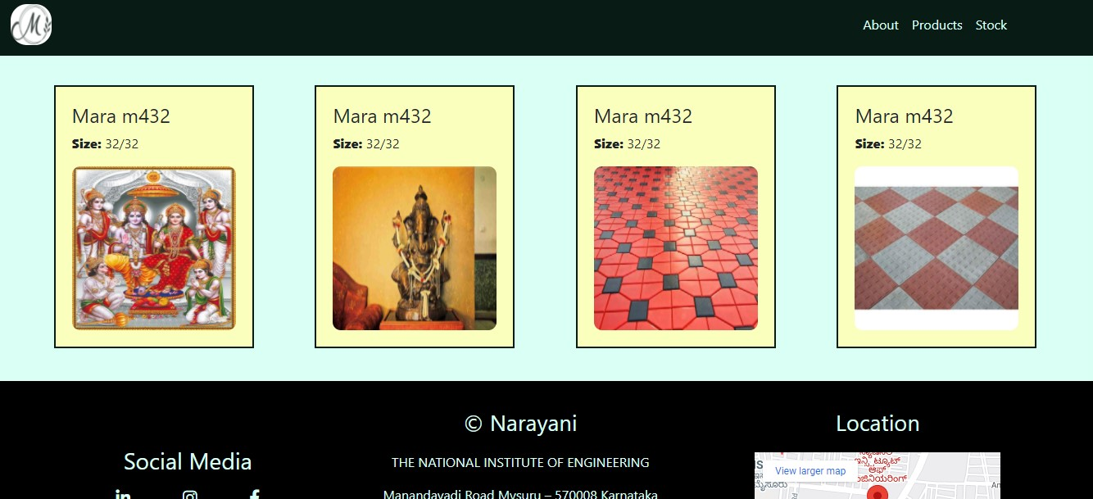

**Fig 4.6 (c) Accessories page**

**4.2 Back end**

Backend is used in making stock page. It has different options like add name, add size, sales entry, purchase entry, graphs, Today's sales, out of stock list, total stock, and all display products sold in the company. We have used PHP language to connect database to front end.

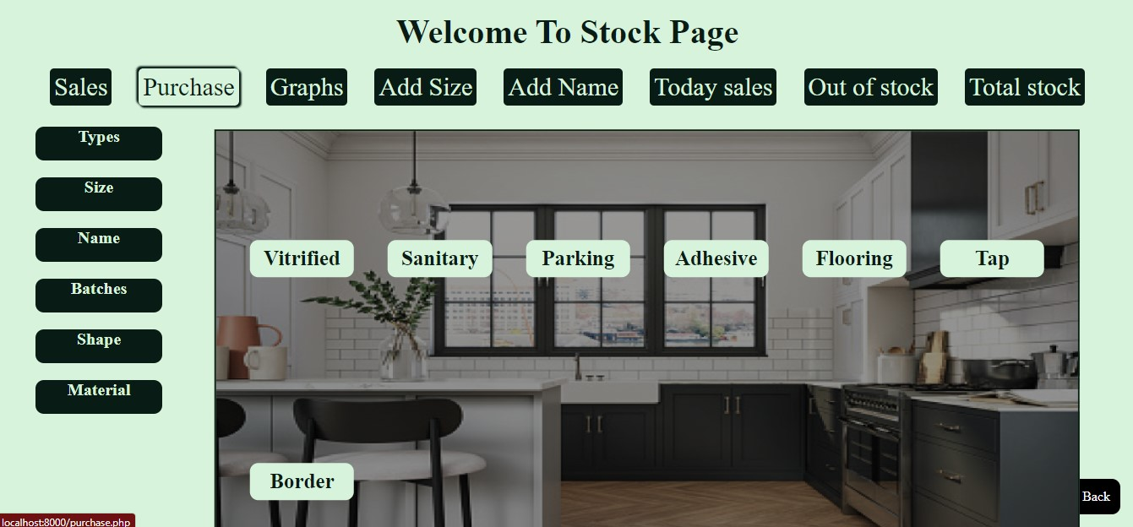

**Fig 4.7 (a) Homepage of stock**

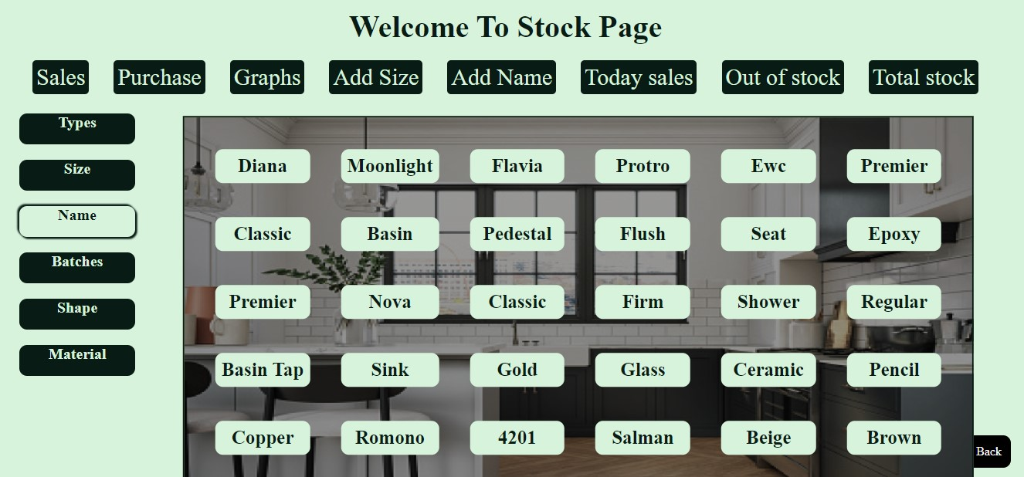

**Fig 4.7 (b) Different types of products**

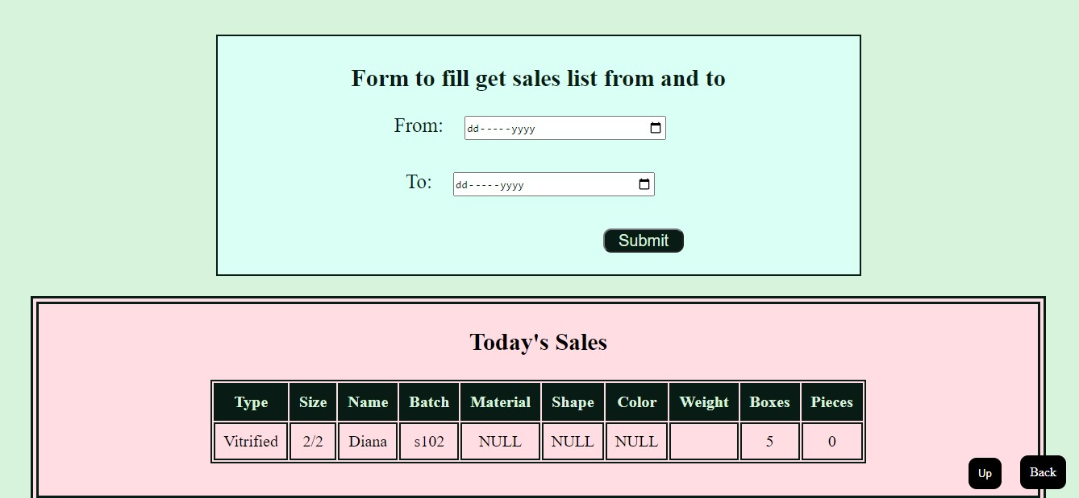

**Fig 4.7 (c) Today’s sales**

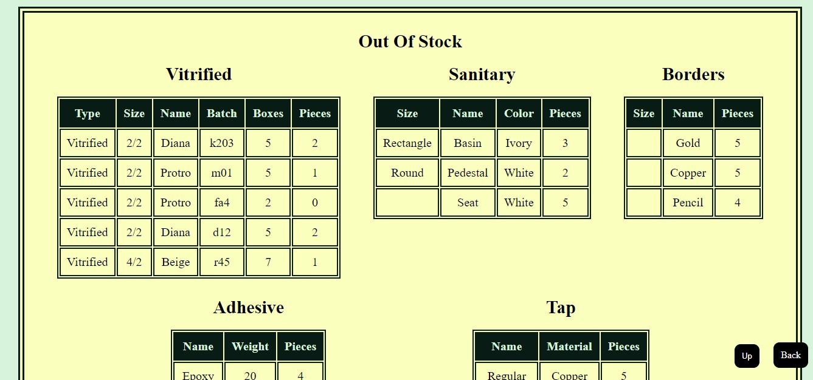

**Fig 4.7 (d) Out of stock**

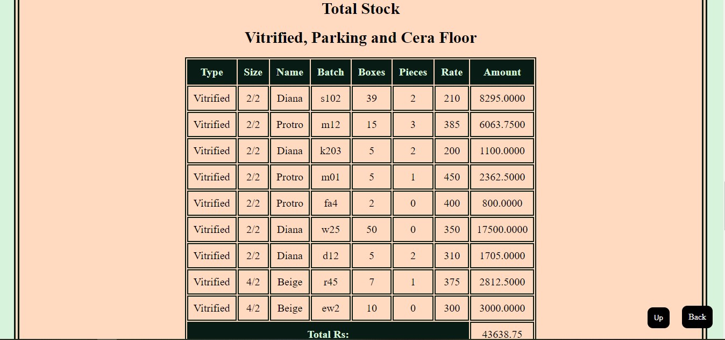

**Fig 4.7 (e) Total stock**

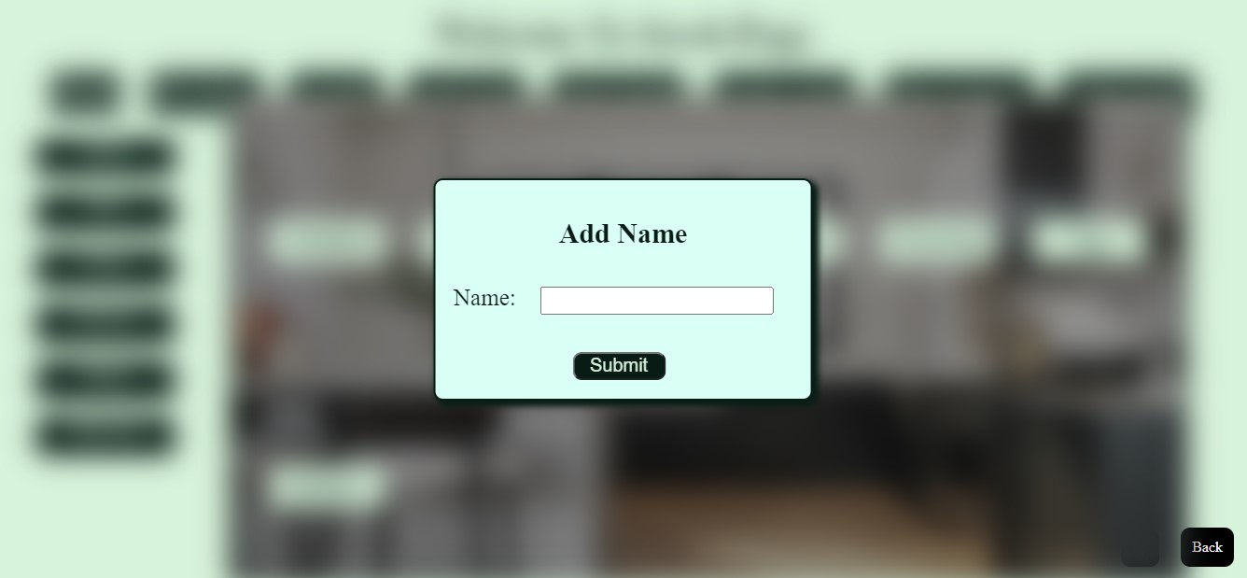

**Fig 4.8 (a) Add name option**

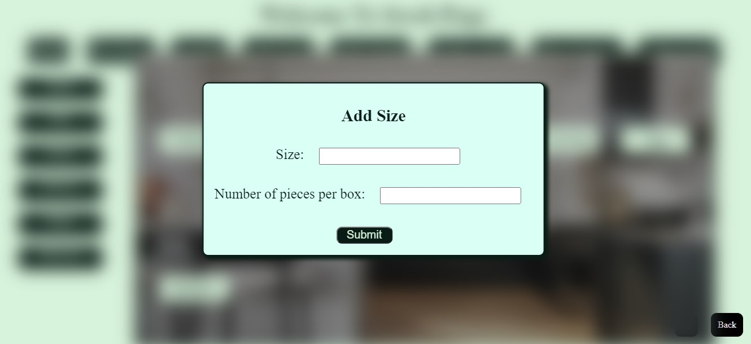

**Fig 4.8 (b) Add size option**

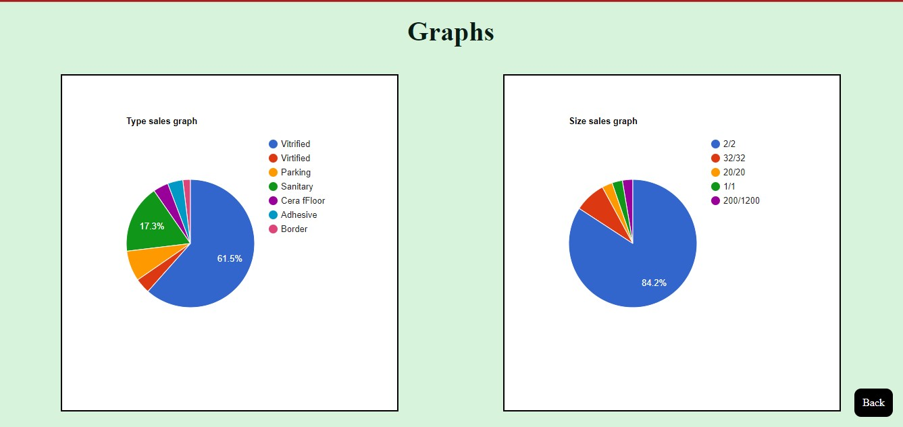

**Fig 4.9 Graphical display of sales**

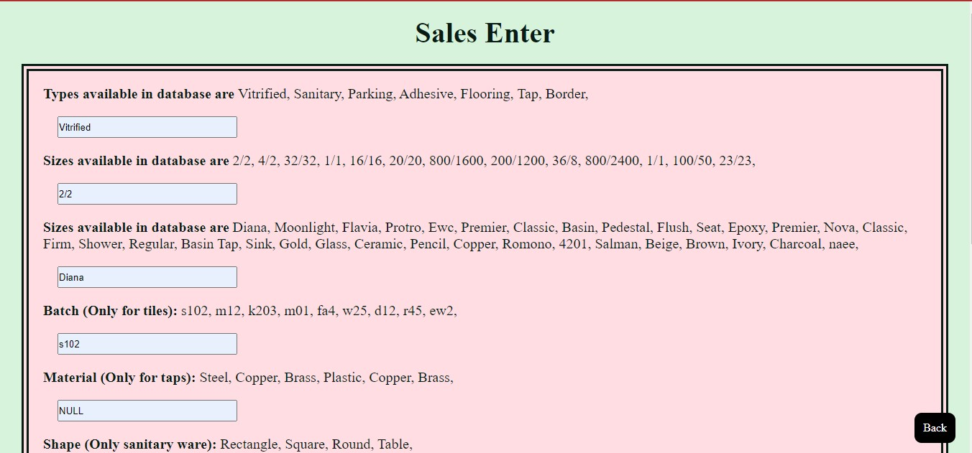

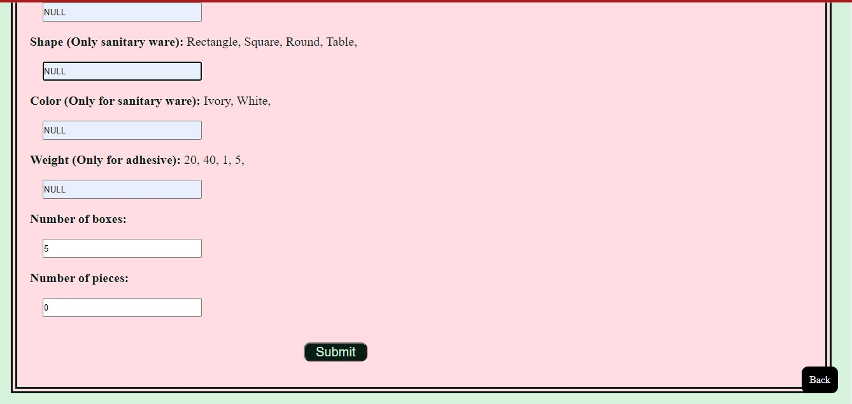

**Fig 4.10 (a) Sales entry form**

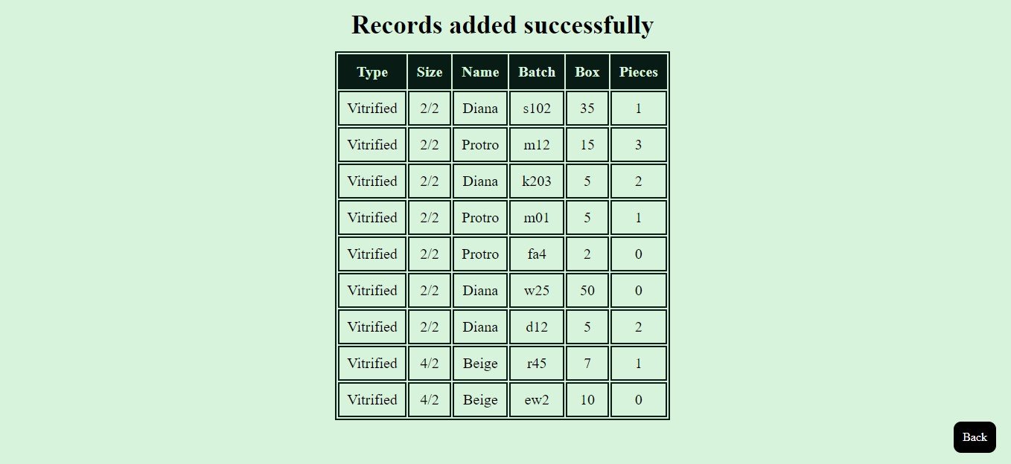

**Fig 4.10 (b) Stock display after sales entry**

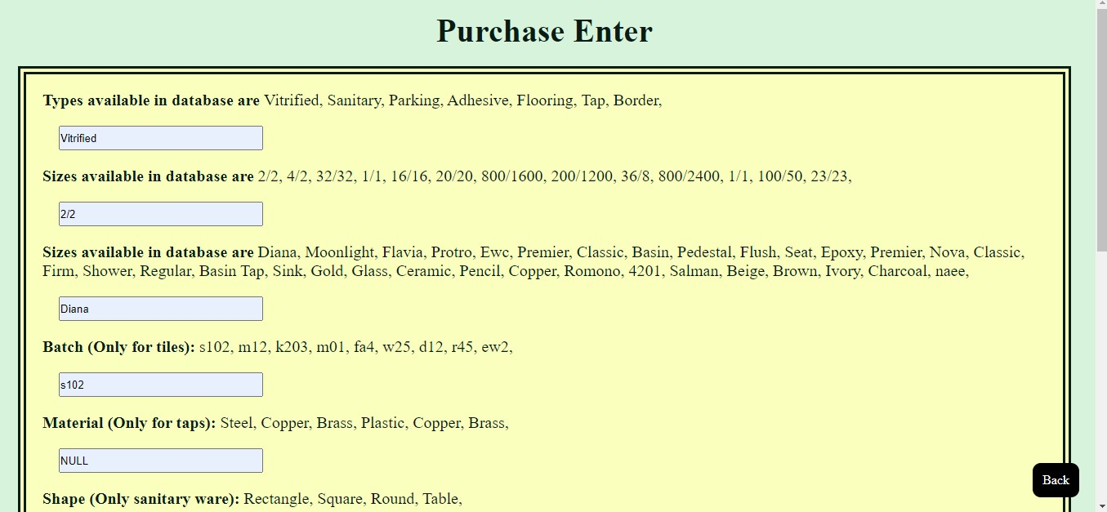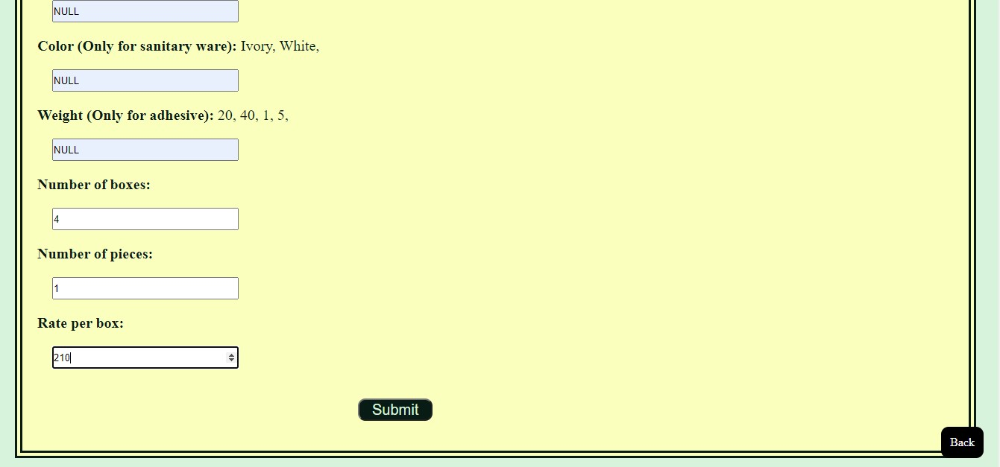

**Fig 4.11 (a) Purchase entry form**

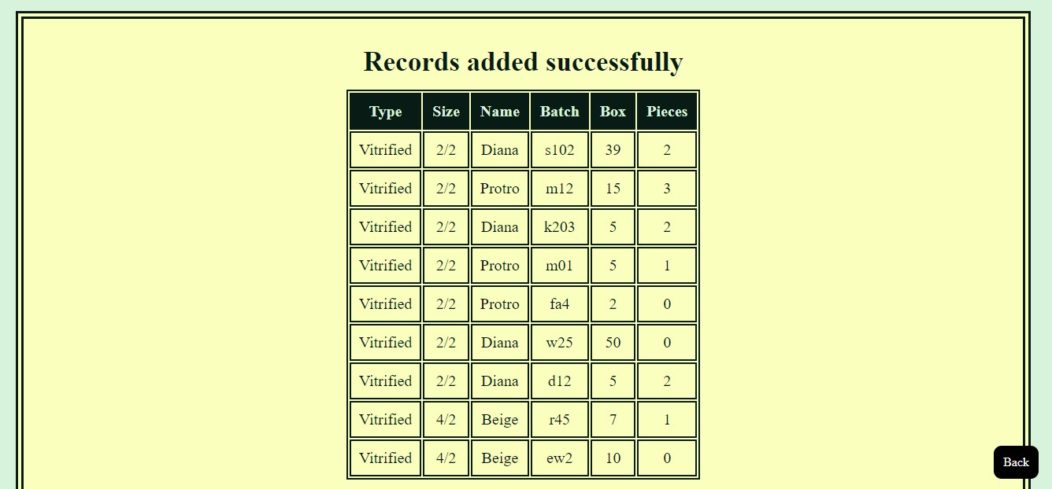

**Fig 4.11 (b) Stock display after purchase entry**

**4.3 Database**

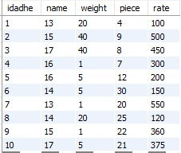

**Fig 4.12 Adhesive table**

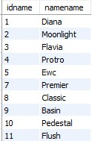

**Fig 4.13 Name table**

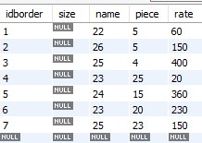

**Fig 4.14 Border table**

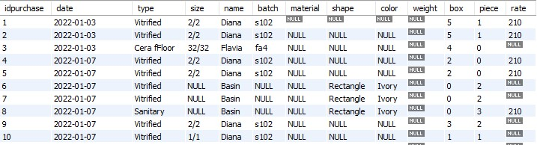

**Fig 4.15 Purchase table**

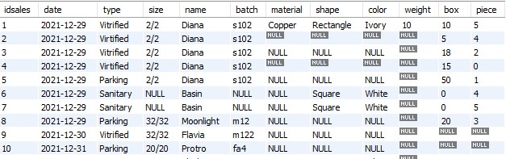

**Fig 4.16 Sales table**

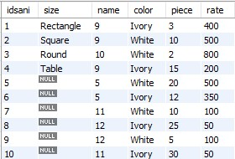

**Fig 4.17 Sanitary table**

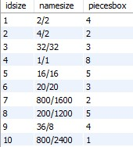

**Fig 4.18 Size table**

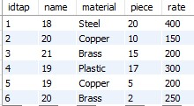

**Fig 4.19 Tap table**

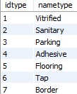

**Fig 4.20 Type table**

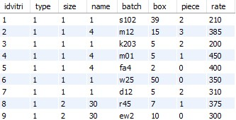

**Fig 4.21 Vitrified table**

**Chapter-5**

**System Testing**

**5.1 Introduction**

Testing is very important and critical to the success of any project that aims at delivering working software. There are many types of testing that a system may be subjected to, however only the ones in the testing objectives will be carried out for this system.

The overall purpose of testing is to ensure that this system meets all of its functional and business requirements. The purpose of this chapter is to describe the overall test plan and strategy for testing the system.

The goal is testing this system include validating the quality, usability, reliability and performance on the application. Testing will be designed around requirements and functionality.

**5.2 Confirmation Testing**

When a test fails, the defect is reported and a new version of the software is expected to have them fixed. In that case, we need to execute the test again to confirm whether the defect is fixed or not. This is known as confirmation testing also known as re-testing. It is important to ensure that the test is executed in the same way it was done for the first time using the same inputs, data, and environments. Hence, when changes are made to fix then confirmation testing or re-testing is helpful.

**5.3 Regression Testing**

During confirmation testing, the defect got fixed and that part of the application started working as intend. But there might be a possibility that the fix may have introduced a different defect elsewhere in the software.

**Chapter-6**

**Conclusion**

This database was successfully created and has stored all the details regarding tiles stock. The database was tested very well and the errors were properly debugged. The test also concluded that the performance of the database was very robust. All the necessary output was generated. This system thus provides an easy way to store all the data regarding the tiles. It was concluded that the application works very well and satisfies the needs. Hence, the front end is available to provide a good user interface and real-time access to the data. Hence, the whole project is concluded.